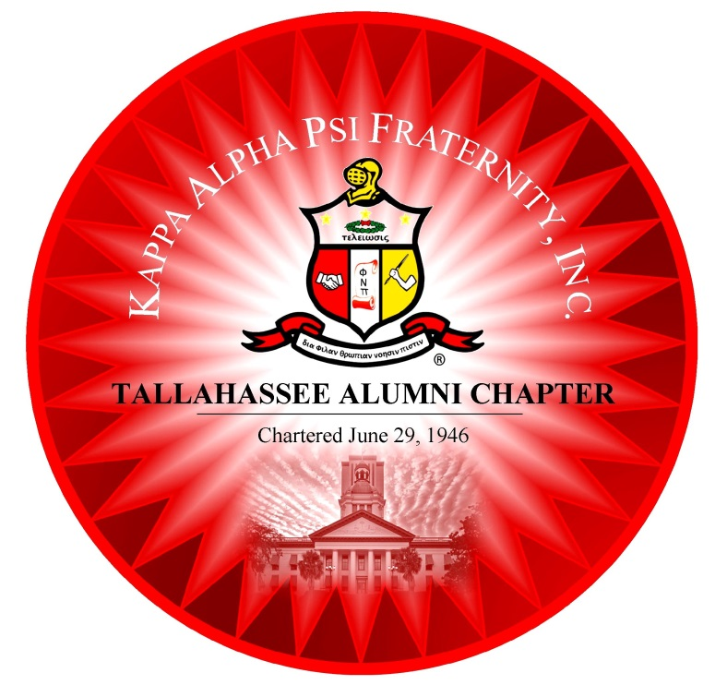
“Live Everyday to Achieve your Dreams”

Tallahassee Alumni Chapter
P. O. Box 6895 Tallahassee, FL 32314
www.tallahasseealumni.com

Tallahassee Alumni Fraternity House
(Current Meeting Location)
2047 Summer Lane Tallahassee, FL 32305

The Norman J. Clement, DDS – Tallahassee Alumni
Leadership, Academic, Community Development Center
730 Wailes Street Tallahassee, FL 32310

Thomas L. Battles, Jr., Grand Polemarch
Bertrum Orum, Province Polemarch

Ernest J. Lane, Chapter Polemarch
ernestjlane@aol.com 850-459-5706

Committee Meetings and Board of Directors Meetings
Wednesday, the week before the 3rd Thursday at 6pm
~~~~~~~~~~~~~~~~~~~~~~~~~~~~~~~
Formal Fraternity Meetings
The 3rd Thursday of each month (September – June) 8pm
Dinner Served
2015-2016 Kalendar of Events
AUGUST
11-16 | Grand Chapter Meeting | New Orleans, LA
18 | Housing Concerns | 6 pm 730 Wailes Street
19 | Chapter Planning Session | 6 pm Alumni Fraternity House
26 | Chapter Planning Session | 6 pm Alumni Fraternity House
SEPTEMBER – Monday Night Football – BYOB/Snacks
2 | Chapter Planning Session | 6 pm Alumni Fraternity House
7 | “Labor Day” New Membership Program Training – Lunch will be served | 11 am – 3 pm Alumni Fraternity House
9 | Committee/Board of Directors Meeting | 6 pm Alumni Fraternity House
17 | Formal Chapter Meeting – Coat & Tie Required – State of the Chapter | 8 pm Alumni Fraternity House
20 | Public Meeting – Back to School | 4 pm
26 | St. Jude’s Walk/Run to End Childhood Cancer | 8am Southwood Town Center
OCTOBER – Monday Night Football – BYOB/Snacks
7 | Committee/Board of Directors Meeting | 6 pm Alumni Fraternity House
15 | Formal Chapter Meeting – Coat and Tie Required | 8 pm Alumni Fraternity House
16/17 | Homecoming Tailgate/Fundraiser-Seafood Feast | 5pm/11am – after game
31 | HALLOWEEN
NOVEMBER – Monday Night Football – BYOB/Snacks
6 | All Black Masquerade Fundraiser | 9pm – Cross Creek Banquet Room
11 | VETERANS DAY LUNCHEON / Honor our Chapter Veterans | 12noon – Alumni Frat House
11 | Committee/Board of Directors Meeting | 6 pm Alumni Fraternity House
13-15 | CRWL Conference/MTA (formerly MOIP) | Hyatt/Jacksonville, FL
19 | Formal Chapter Meeting – Coat and Tie Required | 8 pm Alumni Fraternity House
20 | Public Meeting | 4 pm
26 | THANKSGIVING DAY
DECEMBER – Monday Night Football – BYOB/Snacks
5 | Riley House Rock A Thon (Friday Prep – Saturday Perform) | 7am-5pm The Riley House
9 | Committee/Board of Directors Meeting | 6 pm Alumni Fraternity House
17 | Formal Chapter Meeting – Coat and Tie Required | 8 pm Alumni Fraternity House
18 | Holiday Party Fundraiser | 9pm – Leon County Fairgrounds
20 | Public Meeting – Christmas Karols by the Kappa Khoir (Silhouettes) | 6pm – St. John M. B. Church
25 | CHRISTMAS DAY
JANUARY 2015
1 | NEW YEAR’S DAY
5 | KAPPA ALPHA PSI FOUNDED – J-5 Social (Brothers Only) | Alumni Fraternity House
7-9 | National Founders Day | Mobile, AL
13 | Committee/Board of Directors Meeting | 6 pm Alumni Fraternity House
16  16  17 | TLH AL – Alpha Xi – Theta Eta – Kappa League Founders Day Activities  Closed Banquet – Grand Polemarch Thomas L. Battles, Sr., Speaker  Public Meeting | Gaither Gym  University Club/UCC at FSU  St. John M. B. Church
18 | MLK, Jr. Day Activities | Downtown Tallahassee
21 | Formal Chapter Meeting – Coat and Tie Required | 8 pm Alumni Fraternity House
FEBRUARY
10 | Committee/Board of Directors Meeting | 6 pm Alumni Fraternity House
13 | VALENTINE’S DAY – 70s/Fundraiser/Sweetheart Affair | 8pm – Cross Creek Banquet Room
18 | Formal Chapter Meeting – Coat and Tie Required | 8 pm Alumni Fraternity House
26 | Black History Game Night (Trivia, Card, Chess, Checkers etc.) | Alumni Fraternity House
MARCH
9 | Committee/Board of Directors Meeting | 6 pm Alumni Fraternity House
17 | Formal Chapter Meeting – Coat and Tie Required | 8 pm Alumni Fraternity House
19 | Spring Fling – Foundation Event | Gadsden County
27 | Student of the Year Competition | TBD
31-4/3 | Southern Province Council Meeting | Westin – Huntsville, AL
APRIL
3/31-4/3 | Southern Province Council Meeting | Westin – Huntsville, AL
6 | Committee/Board of Directors Meeting | 6 pm Alumni Fraternity House
14 | Formal Chapter Meeting – Coat and Tie Required | 8 pm Alumni Fraternity House
22 | HGP Kappa Klassic Golf Tournament – Foundation Event | TBD
 | Province Council | Huntsville, AL
MAY
11 | Committee/Board of Directors Meeting | 6 pm Alumni Fraternity House
19 | Formal Chapter Meeting – Coat and Tie Required - Elections | 8 pm Alumni Fraternity House
21 | Black & White Ball Scholarship Gala | 9 pm Civic Center
22 | The Kappa League – Guide Right Beautillion | Time & Location TBA
JUNE
8 | Committee/Board of Directors Meeting | 6 pm Alumni Fraternity House
16 | Formal Chapter Meeting – Coat and Tie Required – Install Officers | 8 pm Alumni Fraternity House
25/26 | (Summer Affair) Kappa Family Charter Day Celebration /70th Anniv. | 2-5pm Alumni Fraternity House
JULY
1-3 | Alpha Xi Family Reunion | 730 Wailes Street
4 | Independence Day | The Muldrows
TBA | Chapter Planning Session | 6 pm Alumni Fraternity House
TBA | Chapter Planning Session | 6 pm Alumni Fraternity House
AUGUST
TBA | Chapter Planning Session | 6 pm Alumni Fraternity House
TBA | Chapter Planning Session | 6 pm Alumni Fraternity House
r8/18/2015

On Saturday night, June 29, 1946, 14 Kappa Men of Tallahassee, Florida, confirmed their inclination to establish a local alumni chapter. It was at the Mount Olive Masonic Lodge Hall, located at the southwest corner of Macomb and Tennessee Streets, that these inspired men, presided over by then Southeastern Province Polemarch W. Dickerson Donnelly, chartered what is now known as the Tallahassee Alumni Chapter of Kappa Alpha Psi Fraternity, Inc.
The charter members were Brothers Leonard S. Walker, Polemarch; Cornelius M. Speed, Jr., Vice Polemarch; James L. Bruton, Keeper of Records; Vandon R. Jones, Sr., Keeper of Exchequer; James O. Mobley, Strategus; Phillip J. Nelson, Historian & Reporter, Robert Jones, Wallace Stevens, J. R. E. Lee, Jr., Melvin R. Kyler, Sylvester L. Beasley, Harold S. Jenkins, R. Frank Nims, Sr., and Elbert Jones.
The Tallahassee Alumni Chapter is continuing to achieve in every field of human endeavor, having accomplished much over the past 69 years. Under the leadership of 27Polemarchs, approximately 120 men have been initiated into the Tallahassee Alumni Chapter. A number of our members have and are now serving as National Officers, National Committee Chairmen, Provincial Officers and Provincial Committee Chairmen. One of our former members, Brother Thomas L. Battles, is currently serving as the 33rd Grand Polemarch. In April 1996, The Tallahassee Alumni Chapter purchased one acre of land with three dwellings; the mortgage was satisfied in October 2013. On June 29, 2015, the Kappa Alpha Psi Southern Province Foundation, Inc. transferred ownership of the 730 Wailes Street property (formerly The Southern Province Memorial House) to Tallahassee Alumni Holding, Inc. (an affiliate of Tallahassee Alumni Chapter).
Our current officers are: Ernest J. Lane, Polemarch Herbert G. Baily, Vice Polemarch
850-459-5706 850-264-5492

Michael J.L. Smith, Keeper of Records John M. Grayson, Keeper of Exchequer Michael R. Moore, Reporter
850-728-4690 850-294-1750 850-251-1658

Antonio Witherspoon, Strategus Lewis K. Johnson, Lt. Strategus Jay Cromuel, Historian
904-347-6938 850-556-6112 850-559-9249

Thomas A. Bush, Bd of Directors Michael O. Johnson, Bd of Directors William R. Muldrow, Sr., Bd of Directors
850-980-2076 954-297-7282 850-933-7271

2015-16 Host Committees
SEPTEMBER 2015  Patrick D. Baggett-El  Herbert G. Bailey  Gilbert T. Brown  Albert E. Bush⋆*  Thomas Bush⋆  Matthew M. Carter, II⋆  Clayton Clark, Sr.⋆ | JANUARY 2016  Ernest J. Lane⋆◊  James F. Mathews, Jr. ⋆  Alaric H. Mathis⋆◊  Irving L. Mills, Jr. ⋆  Michael R. Moore⋆◊♠  Charles A. Morris⋆  William R. Muldrow, Jr. ⋆  William R. Muldrow, Sr. ⋆* | MAY 2016  Virden Evans, III  Sean Brown  Laverne Washington  Alan Williams  Lawton Williams, Jr. ⋆  Antonio A. Witherspoon  Robert A. Woolfork⋆◊*
OCTOBER 2015  Selvin Cobb⋆◊  James E. Cole, Jr.  Ralph G. Coleman, Jr.  Jay Cromuel  Cornell Cummings⋆  Booker Daniels*  Jerome G. Dilworth, Sr. ⋆ | FEBRUARY 2016  Toraino S. Owens⋆◊  Sean Pittman⋆  Michael O. Randolph  Alton W. Royal⋆◊  Bernard Scott, Sr.  Edward R. Scott, II⋆◊♠  Fred Seamon⋆ | JUNE 2016  Reclamation Brother  Reclamation Brother  Reclamation Brother  Reclamation Brother  Reclamation Brother  Reclamation Brother  Reclamation Brother  Reclamation Brother  Reclamation Brother  Reclamation Brother
NOVEMBER 2015  George Drumming, Jr. ⋆  Kelvin D. Farmer  Joel Gamble, Jr.  Carl B. Goodman  John M. Grayson⋆◊  John Hamilton⋆*  J. Leonard Hamilton⋆ | MARCH 2016  Christopher Small  Andre Smith  Michael J.L. Smith⋆  Reginald A. Smith, Jr.  Reginald A. Smith, Sr.⋆  Rodney N. Smith, Sr. ⋆◊  Mike M. Supplice | All chapter members are encouraged to join/attend any Committee Meeting:  6pm  Standing Committees  *Audit *Awards  *Benevolence *Black & White  *Budget * By-Laws  *Founders Day *Fund Raising  *Guide Right *Legal  *Housing & Properties  *Investigations *Nominations  *Long Range Planning  *Membership Training Academy (Formerly MOIP)  *Past Polemarchs Council  *Reclamation *Scholarship  *Silhouettes *Social Action  *Summer Affair *Technology  *Undergraduate Affairs
DECEMBER 2015  Ronte Harris  Chauncy E. Haynes⋆◊♦  Thomas Haynes⋆  Marlon S. Honeywell⋆  Lewis K. Johnson  Michael O. Johnson  Otis W. Kirksey | APRIL 2016  Kenneth E.M. Taite  John C. Thomas⋆  Edward G. Tolliver⋆  Rhett Turnquest⋆  Anthony O. Viegbesie⋆  Mark A. Weatherspoon  Julian E. White⋆*

ALL MEETINGS WILL BE HELD AT THE ALUMNI FRATERNITY HOUSE UNLESS OTHERWISE NOTIFIED. 8/18/2015

